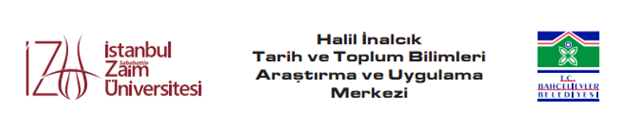

A Seminar Entitled
Pan-Islamic International Cooperation and Anticolonialism: South Asia, Turkey, and Southeast Asia
by Dr. Arshad Islam
Departman of History & Civilization
International Islamic University Malaysia
Email: arshad@iium.edu.my

IZU Halkali Campus, Library Conference Room at 3:00 to 4:30 p.m. on Thursday October 24, 2019

Abstract

Non-Western cultures and peoples, such as the Islamic, Hindu, Confucian, and Orthodox Christian, have been systematically oppressed, colonized, and dominated by the ideology, arms, and economies of the West for over two centuries under the imperialist ‘clash of civilizations’. Numerous techniques have been adopted by the oppressed peoples of Asia, Africa, and Latin America to resist this domination, and to promote peace, harmony, and stability. One of these strategies that was manifest during the anticolonial movement in South Asia, Turkey, and Southeast Asia was pan-Islamism, which was relatively forgotten by history until Turkey more recently began to assume its historic role as a leading civilization in Asia and the wider Muslim world. Most modern development literature is premised on the assumption that Western civilization is the model to which all developing nations must aspire, and assistance in economic development is generally premised on accepting a raft of Western neo-imperialist demands that may be contrary to Asian and African cultural mores. In response to this, nationalist movements have become increasingly skeptical about international development agenda, and Eurasian countries such as Russia, Turkey, Pakistan, India, and China are increasingly rejecting subservience to the political and cultural demands of the West. This paper explores examples of the role of pan-Islamism in resisting European colonialism. It particularly analyses the role of Indian Muslims in assisting the Ottoman Caliphate (e.g. financing the Hejaz Railway and supporting the Turkish cause during the Balkan Wars), the role of the Ottomans in Sumatran resistance to Dutch colonialism, and the resumption of pan-Islamic ties manifest in modern Turkish disaster relief efforts in Indonesia. It concludes that pan-Islamism is already a powerful force in international development. It shows that the pan-Islamic platform offers great scope for developing countries to autonomously assist each other without the shackles of the neo-imperialist agendas, recovering their historical position and dignity as vibrant, compassionate societies.

Biodata of Dr. Arshad Islam 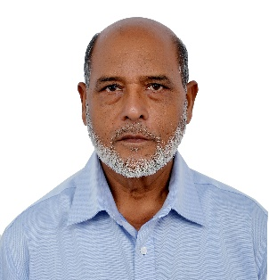

Dr. Arshad Islam, Associate Professor, holds B.Sc. and M. A. degrees from Gorakhpur University, and M. Phil. and Ph.D. from Aligarh Muslim University, India. He joined International Islamic University Malaysia in 1991 and has taught a number of courses in Southeast Asian history, Indian history, History of Science, Islamic History and Civilization, Rise and fall of Civilizations, and Central Asian history. His research interests include the Malay Sultanates, the coming of Islam to South and Southeast Asia, and Central Asian history. His latest publications include: Islam in Sindh (Kuala Lumpur: IIUM Press, 2001), and articles on Islamic reform movements, “The Spread of Islam in Central Asia: A Comparison with Southeast Asia” (2010), “The Contribution of Muslims to Science during the Middle Abbasid Period (750-945),” “The Rise of the Seljuqs and their State in Central Asia (2013)”, “The Mongol invasions of Central Asia”, International Journal of Social Science and Humanity (2016), The Spread of Islam in India and Southeast Asia (2017), “Bureaucracy: Max Weber’s Concept and Its Application to Pakistan”, Journal of International Relations and Diplomacy (2018), “Indian Muslims’ Support for Ottoman Pan-Islamism: The Case of Shibli Nu’mani”. Dr Arshad won “Gold Medal” for Research Invention and Innovation 2011 and 2013 (IRIIE 2011, 2013), International Islamic University Malaysia. He was Chairman of the International Conference on Colonialism and Decolonization: Challenges and Prospects, organized by the Department of History and Civilization, IIUM, in 2012. He has been invited to deliver papers in Azerbaijan, Canada, India, Italy, Kazakhstan, Kirgizstan, Pakistan, the Philippines, Taiwan and Turkey, on topics related to history and Islamic civilization.

Prof. Dr. Mehmet Mehdi İlhan
Director of İZU Halil İnalcık Research Center
Halkalı - İstanbul

